Anthony D’Alessandro

Probability and Applied Statistics – MATLAB CSV Programs Demo & Discussion

**Methods**

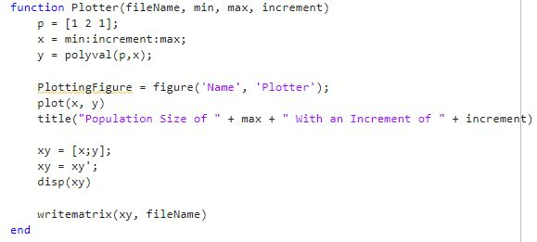Plotter

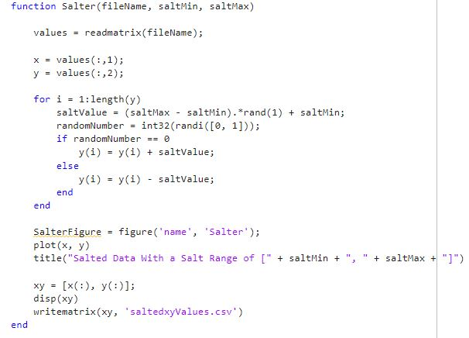Salter

Smoother

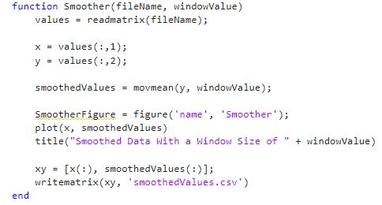

**Small Scale Trial**

Function Used: $x^{2}+2x+1$

Plotter

* Data generated using a population range from [1, 50] with an increment of 0.5



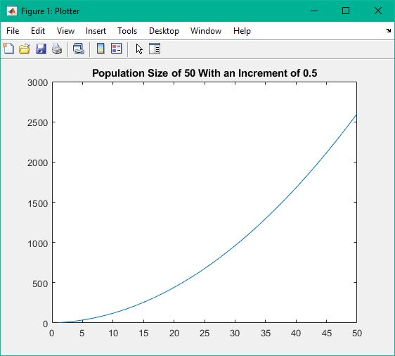

Salter

* Data salted with a salt range from [0, 250]



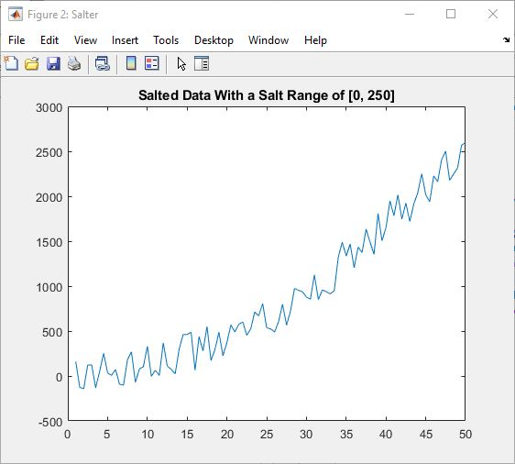

Smoother

* Data smoothed with a window size of 8



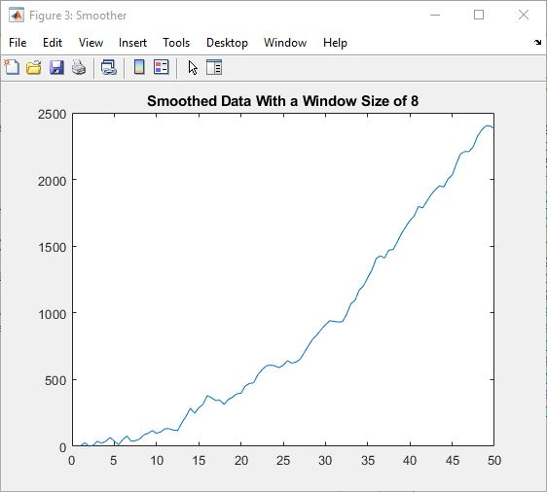

Smoother (Run 2)

* Smoother ran on first set of smoothed data with a window size of 8



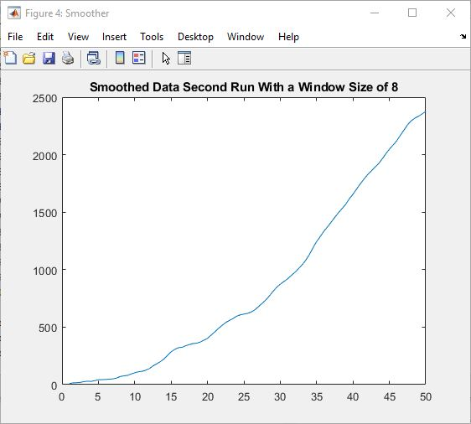

Smoother (Run 3)

* Smoother ran on second set of smoothed data with a window size of 8



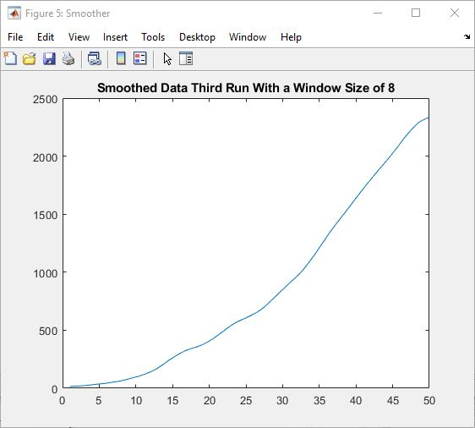

**Larger Scale Trial**

Function Used: $x^{2}+2x+1$

Plotter

* Data generated using a population range from [1, 500] with an increment of 0.5



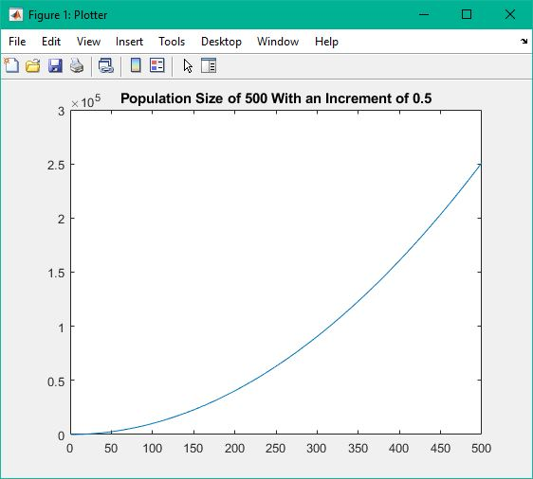

Salter

* Data salted with a salt range from [0, 100000]



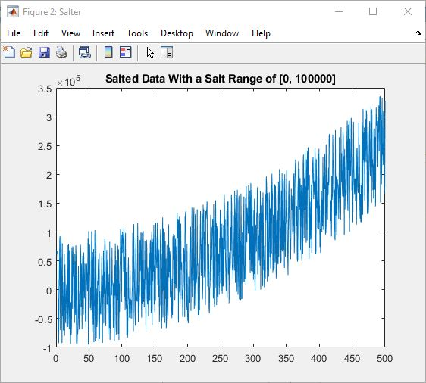

Smoother

* Data smoothed with a window size of 25



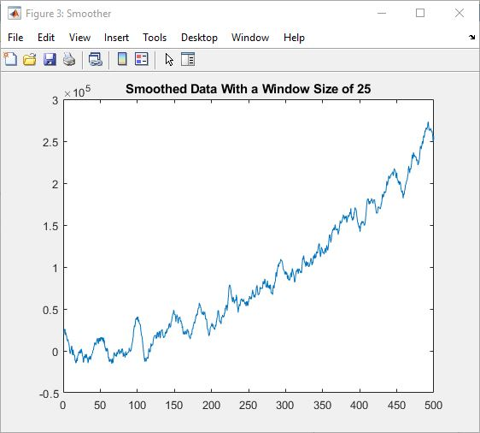

Smoother (Run 2)

* Smoother ran on first set of smoothed data with a window size of 25



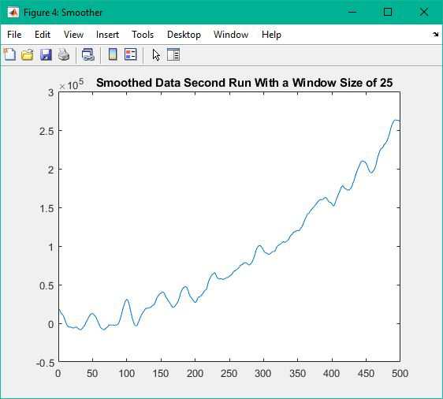

Smoother (Run 3)

* Smoother ran on second set of smoothed data with a window size of 25



